# a)

import numpy as np

import matplotlib.pyplot as plt

n = [1, 5, 10, 20, 30, 50]

a = 5

x = np.linspace(0, 1, 1e7)

for i in range(0, 5):

plt.plot(x, x**n[i] / (x + a))

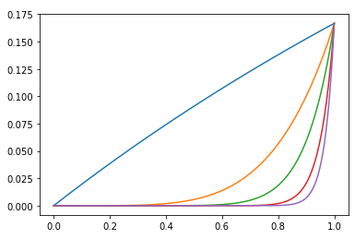

# b)

import math

import numpy as np

def f(a, n0, n1, y0):

# set yn as an array with size of |n1 - n0|

yn = np.zeros(np.absolute(n1 - n0) + 1)

# calculate yn0

yn0 = y0

if n0 > 0:

for j in range(1, n0 + 1):

yn0 = 1 / j - a * yn0

# iteration from n0 to n1

yn[0] = yn0

if n1 > n0:

for k in range(n0 + 1, n1 + 1):

yn[k - n0] = 1 / k - a * yn[k - n0 - 1]

if n1 < n0:

for l in range(n0 + 1, n1 + 1, -1):

yn[l - n0] = (1 / l - yn[l - n0 - 1]) / a

return yn

# c)

print (f(5, 0, 30, math.log(((1 + 5) / 5) )))

x = float(input("Set y0: ")) # read y0 from input

print (f(5, 50, 30, x))

# Result:

